Software requirements

Download Xampp from <https://www.apachefriends.org/download.html>

Download latest version of php 8.2.12 + (Feb 2024)

How to open mysql server

Go to xampp control panel and start apache server and mysql server

Then go to browser and enter URL <http://localhost/phpmyadmin/>

From home page of mysql server select databases section and create new database.

**MySQL Tutorial**

MySQL is a widely used relational database management system (RDBMS).

MySQL is free and open-source.

MySQL is ideal for both small and large applications.

# Introduction to MySQL

MySQL is a very popular open-source relational database management system (RDBMS).

## What is MySQL?

* MySQL is a relational database management system
* MySQL is open-source
* MySQL is free
* MySQL is ideal for both small and large applications
* MySQL is very fast, reliable, scalable, and easy to use
* MySQL is cross-platform
* MySQL is compliant with the ANSI SQL standard
* MySQL was first released in 1995
* MySQL is developed, distributed, and supported by Oracle Corporation
* MySQL is named after co-founder Monty Widenius's daughter: My

## Who Uses MySQL?

* Huge websites like Facebook, Twitter, Airbnb, Booking.com, Uber, GitHub, YouTube, etc.
* Content Management Systems like WordPress, Drupal, Joomla!, Contao, etc.
* A very large number of web developers around the world

## Show Data On Your Web Site

To build a web site that shows data from a database, you will need:

* An RDBMS database program (like MySQL)
* A server-side scripting language, like PHP
* To use SQL to get the data you want
* To use HTML / CSS to style the page

# MySQL RDBMS

## What is RDBMS?

RDBMS stands for Relational Database Management System.

RDBMS is a program used to maintain a relational database.

RDBMS is the basis for all modern database systems such as MySQL, Microsoft SQL Server, Oracle, and Microsoft Access.

RDBMS uses [SQL queries](https://www.w3schools.com/sql/default.asp) to access the data in the database.

## What is a Database Table?

A table is a collection of related data entries, and it consists of columns and rows.

A column holds specific information about every record in the table.

A record (or row) is each individual entry that exists in a table.

Look at a selection from the Northwind "Customers" table:

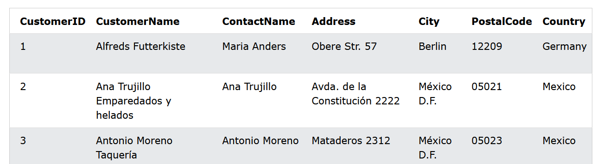

The columns in the "Customers" table above are: CustomerID, CustomerName, ContactName, Address, City, PostalCode and Country.

## What is a Relational Database?

A relational database defines database relationships in the form of tables. The tables are related to each other - based on data common to each.

Look at the following three tables "Customers", "Orders", and "Shippers" from the Northwind database:

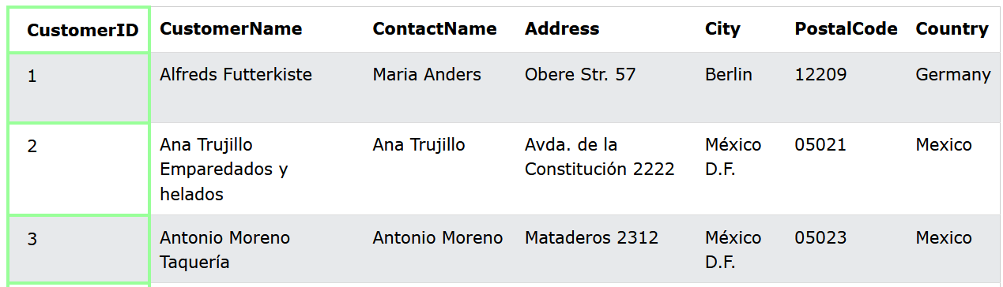

The relationship between the "Customers" table and the "Orders" table is the CustomerID column:

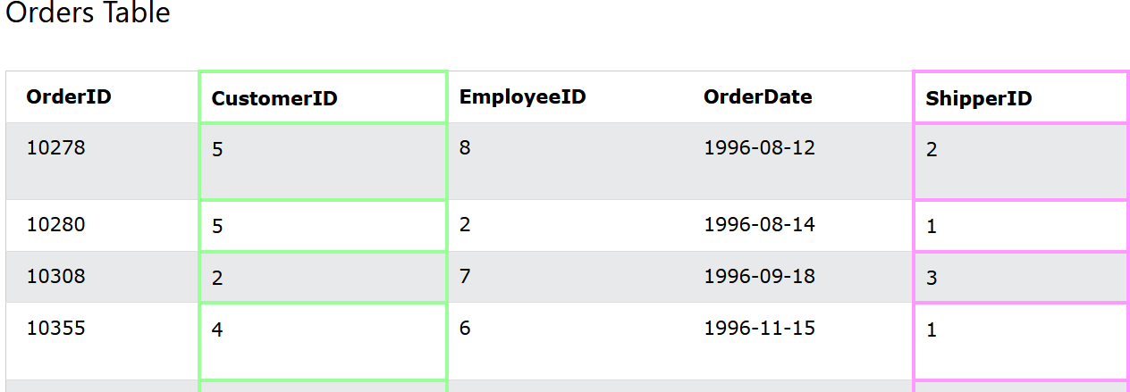

The relationship between the "Orders" table and the "Shippers" table is the ShipperID column:

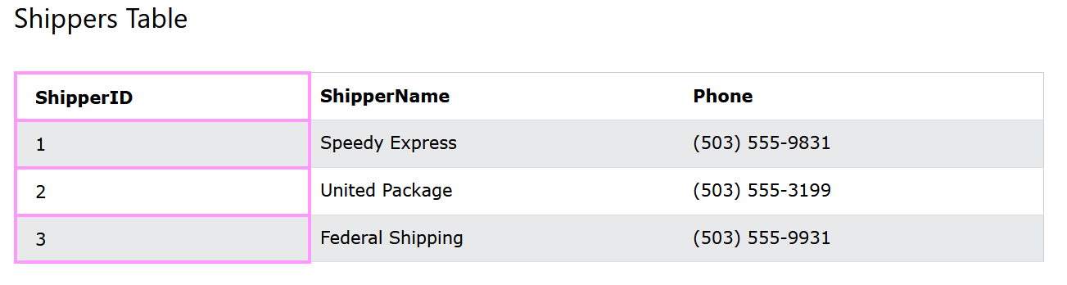

## What is SQL? **(Structured Query Language)**

SQL is the standard language for dealing with Relational Databases.

SQL is used to insert, search, update, and delete database records.

## How to Use SQL

The following SQL statement selects all the records in the "Customers" table:

SELECT * FROM Customers;

## Keep in Mind That...

* SQL keywords are NOT case sensitive: select is the same as SELECT

## Semicolon after SQL Statements?

Some database systems require a semicolon at the end of each SQL statement.

Semicolon is the standard way to separate each SQL statement in database systems that allow more than one SQL statement to be executed in the same call to the server.

## Some of The Most Important SQL Commands

* SELECT - extracts data from a database
* UPDATE - updates data in a database
* DELETE - deletes data from a database
* INSERT INTO - inserts new data into a database
* CREATE DATABASE - creates a new database
* ALTER DATABASE - modifies a database
* CREATE TABLE - creates a new table
* ALTER TABLE - modifies a table
* DROP TABLE - deletes a table
* CREATE INDEX - creates an index (search key)
* DROP INDEX - deletes an index

## The MySQL SELECT Statement

The SELECT statement is used to select data from a database.

The data returned is stored in a result table, called the result-set.

### SELECT Syntax

SELECT column1, column2, ... FROM table_name;

SELECT roll, fname, lname, city, email from students

Here, column1, column2, ... are the field names of the table you want to select data from. If you want to select all the fields available in the table, use the following syntax:

## SELECT * Example

The following SQL statement selects ALL the columns from the "Customers" table:

Select * from students

## The MySQL SELECT DISTINCT Statement

The SELECT DISTINCT statement is used to return only distinct (different) values.

Inside a table, a column often contains many duplicate values; and sometimes you only want to list the different (distinct) values.

### SELECT DISTINCT Syntax

SELECT DISTINCT column1, column2, ... FROM table_name;

SELECT DISTINCT city FROM students

SELECT DISTINCT fname FROM students;

## SELECT Example Without DISTINCT

The following SQL statement selects all (including the duplicates) values from the "Country" column in the "Customers" table:

SELECT city from students

Select count(distinct city ) from students

## The MySQL WHERE Clause

The WHERE clause is used to filter records.

It is used to extract only those records that fulfill a specified condition.

### WHERE Syntax

SELECT column1, column2, ... FROM table_name WHERE condition;

**Note:** The WHERE clause is not only used in SELECT statements, it is also used in UPDATE, DELETE, etc.!

## Text Fields vs. Numeric Fields

SQL requires single quotes around text values (most database systems will also allow double quotes).

However, numeric fields should not be enclosed in quotes:

Select * from students where city = 'rajkot'

Select * from students where roll > 5

Select * from students where not roll > 5;

Select * from students where roll != 5;

## The MySQL AND, OR and NOT Operators

The WHERE clause can be combined with AND, OR, and NOT operators.

The AND and OR operators are used to filter records based on more than one condition:

* The AND operator displays a record if all the conditions separated by AND are TRUE.
* The OR operator displays a record if any of the conditions separated by OR is TRUE.
* The NOT operator displays a record if the condition(s) is NOT TRUE.

### AND Syntax

SELECT column1, column2, ...  
FROM table_name  
WHERE condition1 AND condition2 AND condition3 ...;

### OR Syntax

SELECT column1, column2, ...  
FROM table_name  
WHERE condition1 OR condition2 OR condition3 ...;

### NOT Syntax

SELECT column1, column2, ...  
FROM table_name  
WHERE NOT condition;

SELECT * FROM `students` WHERE roll = 1

SELECT * FROM `students` WHERE roll = 1 and fname = 'udit';

SELECT * FROM `students` WHERE roll = 1 or roll = 2;

SELECT * FROM `students` WHERE roll = 1 or city = 'rajkot';

SELECT * FROM `students` WHERE roll = 1 and city = 'rajkot' or city = 'surat';

SELECT * from students WHERE not city = 'rajkot'

## The MySQL ORDER BY Keyword

The ORDER BY keyword is used to sort the result-set in ascending or descending order.

The ORDER BY keyword sorts the records in ascending order by default. To sort the records in descending order, use the DESC keyword.

### ORDER BY Syntax

SELECT column1, column2, ...  
FROM table_name  
ORDER BY column1, column2, ... ASC|DESC;

SELECT * from students ORDER by fname

SELECT * from students ORDER by fname desc;

SELECT * FROM students ORDER by fname, city

SELECT * FROM students ORDER by fname, city desc

## The MySQL INSERT INTO Statement

The INSERT INTO statement is used to insert new records in a table.

### INSERT INTO Syntax

It is possible to write the INSERT INTO statement in two ways:

1. Specify both the column names and the values to be inserted:

INSERT INTO table_name (column1, column2, column3, ...) VALUES (value1, value2, value3, ...);

2. If you are adding values for all the columns of the table, you do not need to specify the column names in the SQL query. However, make sure the order of the values is in the same order as the columns in the table. Here, the INSERT INTO syntax would be as follows:

INSERT INTO *table_name* VALUES (*value1*, *value2*, *value3*, ...);

INSERT into students (fname, lname, city, email, gender, dateofbirth, phone) values ("Rachit", "Chauhan", "Baroda", "rachit@gmail.com", "male", "2002-02-02", "9900009900")

INSERT into students values ("Rachit", "Chauhan", "Baroda", "rachit@gmail.com", "male", "2002-02-02", "9900009900")

Error : Column count doesn't match value count at row 1

## Insert Data Only in Specified Columns

It is also possible to only insert data in specific columns.

INSERT into students (fname, lname, city, email, gender) values ("Rachit", "Chauhan", "Baroda", "rachit@gmail.com", "male");

## What is a NULL Value?

A field with a NULL value is a field with no value.

If a field in a table is optional, it is possible to insert a new record or update a record without adding a value to this field. Then, the field will be saved with a NULL value.

**Note:** A NULL value is different from a zero value or a field that contains spaces. A field with a NULL value is one that has been left blank during record creation!

## How to Test for NULL Values?

It is not possible to test for NULL values with comparison operators, such as =, <, or <>.

We will have to use the IS NULL and IS NOT NULL operators instead.

SELECT * FROM `students` WHERE phone = '';

SELECT * FROM `students` WHERE dateofbirth = 'NULL'; // no data

SELECT * FROM `students` WHERE dateofbirth is NULL;

SELECT * FROM `students` WHERE dateofbirth is not NULL;

### IS NULL Syntax

SELECT column_namesFROM table_name  
WHERE column_name IS NULL;

### IS NOT NULL Syntax

SELECT column_namesFROM table_name  
WHERE column_name IS NOT NULL;

## The IS NULL Operator

The IS NULL operator is used to test for empty values (NULL values).

**Tip:** Always use IS NULL to look for NULL values.

## The IS NOT NULL Operator

The IS NOT NULL operator is used to test for non-empty values (NOT NULL values).

## The MySQL UPDATE Statement

The UPDATE statement is used to modify the existing records in a table.

### UPDATE Syntax

UPDATE table_name SET column1 = value1, column2 = value2, ... WHERE condition;

**Note:** Be careful when updating records in a table! Notice the WHERE clause in the UPDATE statement. The WHERE clause specifies which record(s) that should be updated. If you omit the WHERE clause, all records in the table will be updated!

UPDATE students set city = 'Gandhinagar' //always use where while update data

update students set fname = 'Yagnik', lname = 'Yadav', city = 'Bhavanagar' WHERE roll = 3

update students set fname = 'Yagnik', lname = 'Yadav', city = 'Bhavanagar' WHERE roll > 3 and roll < 6;

UPDATE students set city = 'Rajkot' WHERE roll >= 5

## UPDATE Multiple Records

It is the WHERE clause that determines how many records will be updated.

## Update Warning!

Be careful when updating records. If you omit the WHERE clause, ALL records will be updated!

UPDATE students set fname = 'tushar', lname = 'kadam' WHERE roll = 4

## The MySQL LIMIT Clause

The LIMIT clause is used to specify the number of records to return.

The LIMIT clause is useful on large tables with thousands of records. Returning a large number of records can impact performance.

### LIMIT Syntax

SELECT column_name(s) FROM table_nameWHERE condition LIMIT number;

SELECT * FROM `students`

SELECT * FROM `students` Limit 5

MySQL provides a way to handle this: by using OFFSET.

The SQL query below says "return only 3 records, start on record 4 (OFFSET 3)":

SELECT * FROM `students` Limit 5 OFFSET 5;

## ADD a WHERE CLAUSE

SELECT * FROM `students` where city = ‘rajkot’ Limit 5

## MySQL MIN() and MAX() Functions

The MIN() function returns the smallest value of the selected column.

The MAX() function returns the largest value of the selected column.

### MIN() Syntax

SELECT MIN(column_name)  
FROM table_name  
WHERE condition;

### MAX() Syntax

SELECT MAX(column_name)  
FROM table_name  
WHERE condition;

SELECT min(roll) FROM students;

SELECT max(roll) FROM students

SELECT max(fees) FROM students

SELECT min(fees) FROM students;

## MySQL COUNT(), AVG() and SUM() Functions

The COUNT() function returns the number of rows that matches a specified criterion.

### COUNT() Syntax

SELECT COUNT(column_name) FROM table_name WHERE condition;

SELECT COUNT(fees) FROM students

SELECT COUNT(fees) FROM students WHERE fees > 10000;

SELECT sum(fees) FROM students WHERE fees > 10000;

SELECT count(fees), sum(fees) FROM students WHERE fees > 10000;

SELECT count(fees), sum(fees), avg(fees) FROM students

The AVG() function returns the average value of a numeric column.

### AVG() Syntax

SELECT AVG(column_name) FROM table_name WHERE condition;

The SUM() function returns the total sum of a numeric column.

### SUM() Syntax

SELECT SUM(column_name) FROM table_name WHERE condition;

## The MySQL DELETE Statement

The DELETE statement is used to delete existing records in a table.

### DELETE Syntax

DELETE FROM table_name WHERE condition;

**Note:** Be careful when deleting records in a table! Notice the WHERE clause in the DELETE statement. The WHERE clause specifies which record(s) should be deleted. If you omit the WHERE clause, all records in the table will be deleted!

## SQL DELETE Example

DELETE FROM students WHERE roll = 5

DELETE FROM students WHERE city = 'rajkot'

## Delete All Records

**It is possible to delete all rows in a table without deleting the table. This means that the table structure, attributes, and indexes will be intact:**

DELETE FROM students

INSERT into students (fname, lname, city, email, gender, dateofbirth, phone, fees) values ("Rachit", "Chauhan", "Baroda", "rachit@gmail.com", "male", "2002-02-02", "9900009900", 15000);

* Add multiple rows and check for roll number

It is possible to delete all the data from table and reset complete structure of the table with truncate clause

TRUNCATE TABLE students

INSERT into students (fname, lname, city, email, gender, dateofbirth, phone, fees) values ("Rachit", "Chauhan", "Baroda", "rachit@gmail.com", "male", "2002-02-02", "9900009900", 15000);

* Add multiple rows and check for roll number // started from 1